Create new angular 6 project.

There are 2 tasks. Both of them are taken from the working project.

# Task 1

Create a sample page to show data in following layout using Flex library. Put a toolbar with dummy icons but align them as shown in the UI.

Show the graphs as shown in the snapshot.

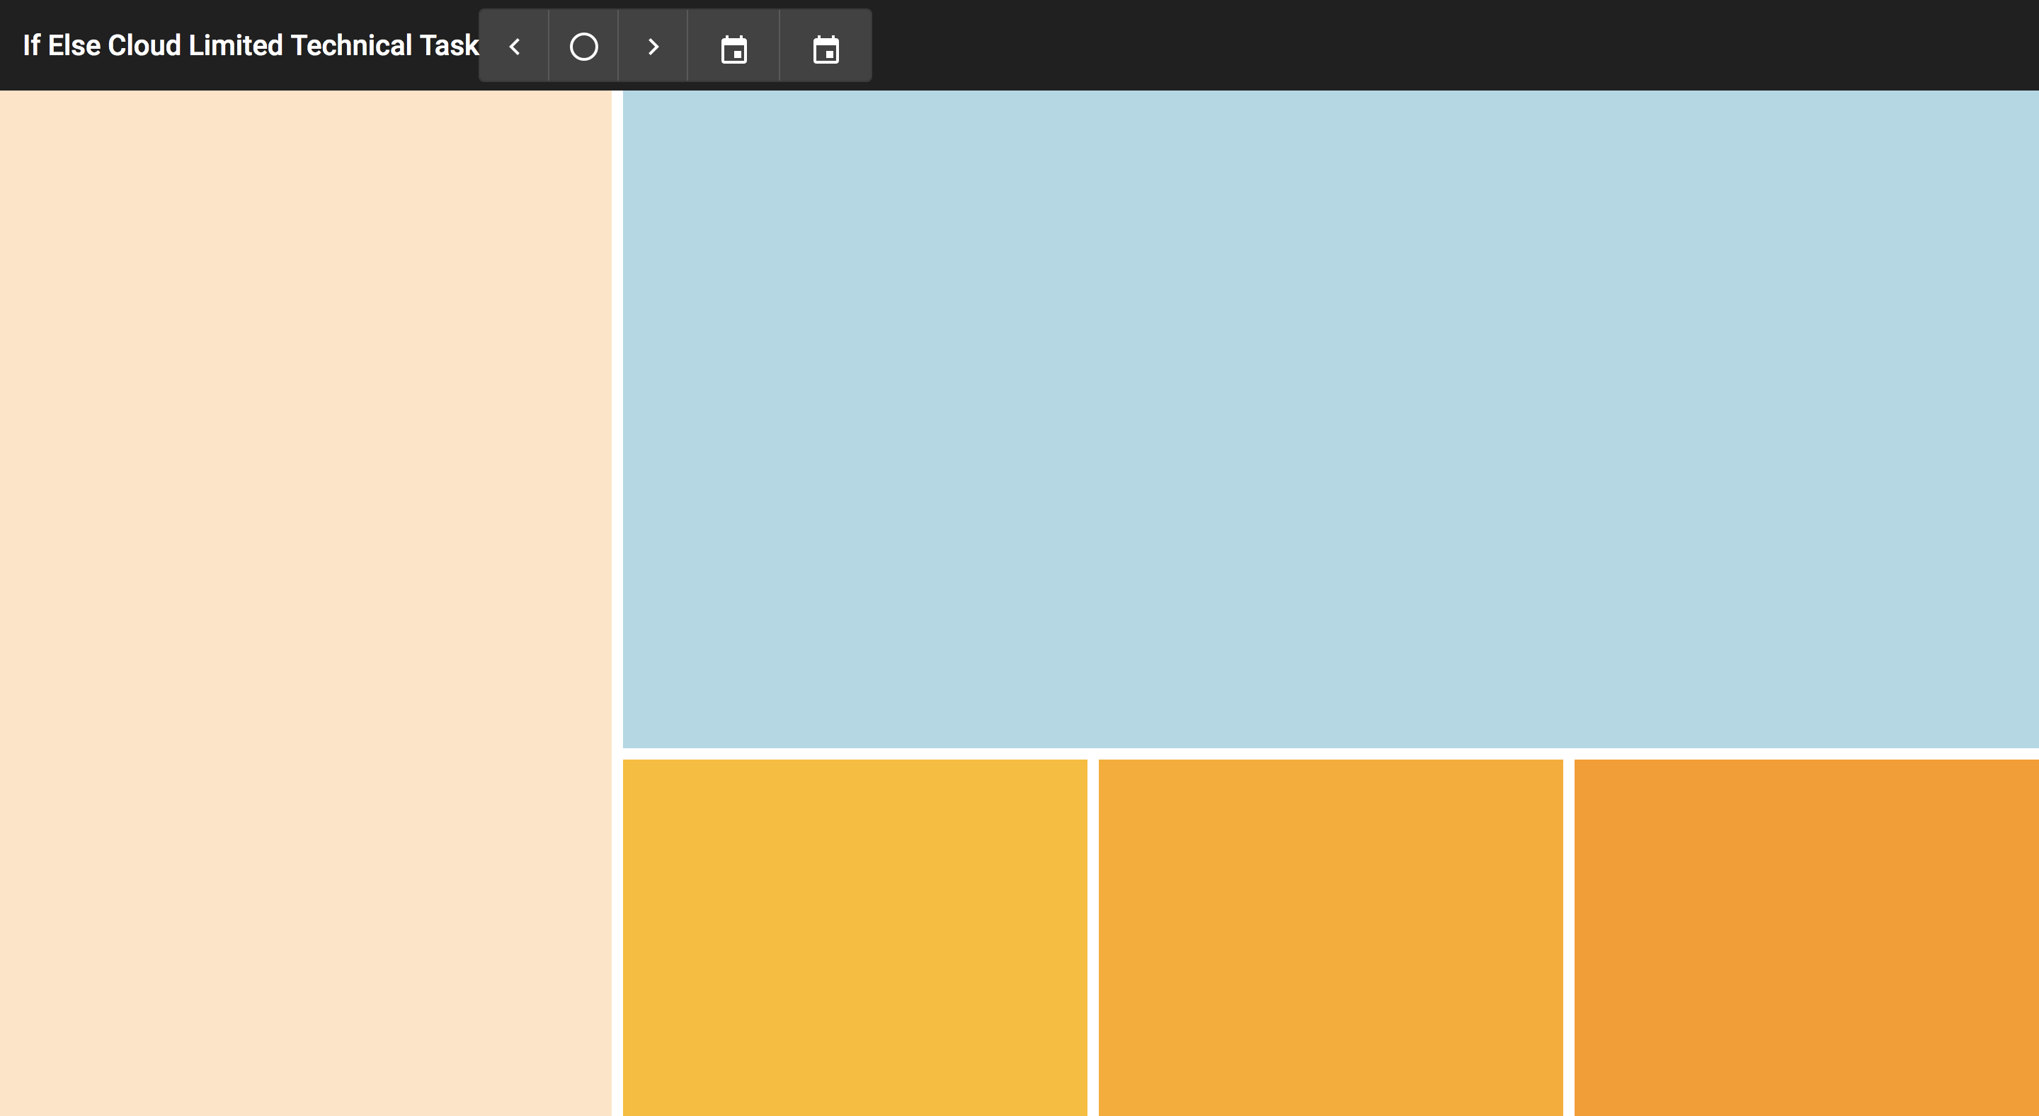

# Task 2

In the blue rectangle add a highcharts, by creating a new module under *reporting* folder. Add ng service in to call API:

API for BarGraph Data

<https://localhost:5005/api/ManufacturingGraph/GetOEEDataBetweenStartEndTimeForGraph?startDate=2019-03-09T19:00:00&endDate=2019-03-19T19:00:00>

The final graph should look like:

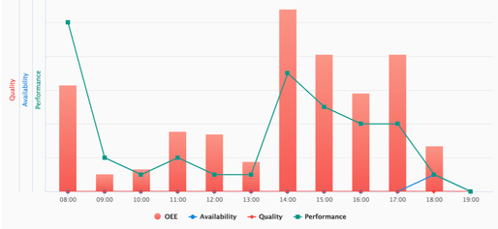

# Task 4

Show in Left long beige box, add the following UI:



# Bonus task:

We have introduced a simple cosmetic bug for this task. While clicking on the Calendar icon, as pointed out, the calendar opens from the left top corner. However, the calendar must open under the icon. Let’s see if you can fix this and impress us!

